**Project Design Phase-II**

**Technology Stack (Architecture &amp; Stack)**

| Date 10 | 16 October2022 |
| --- | --- |
| Team ID | PNT2022TMID22468 |
| Project Name | Plasma Donor Application |
| Maximum Marks | 4 Marks |

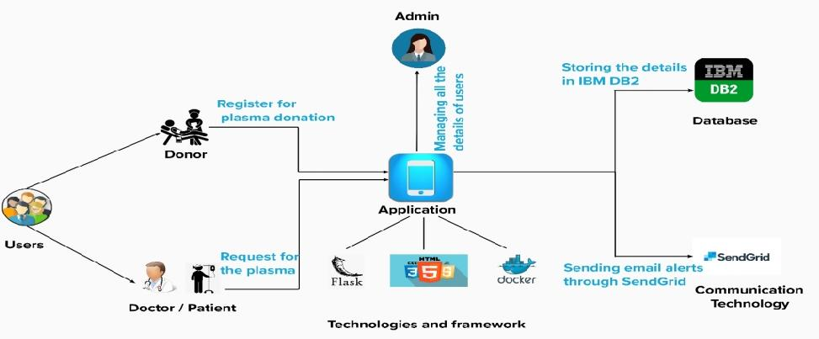

**Table-1 : Components &amp; Technologies:**

| **S.No** | **Component** | **Description** | **Technology** |
| --- | --- | --- | --- |
| 1. | User Interface | The application interacts with the user using chatbot. | HTML, CSS, IBM Watson Assistant, JavaScript / Angular Js / React Js etc. |
| 2. | Application Logic-1 | Framework used for designing the application. | Python - flask |
| 3. | Application Logic-2 | Communication between users and the application via mails. | SendGrid |
| 4. | Application Logic-3 | Storing the details of the users both donors and patients. | IBM DB2 |
| 5. | Application Logic-4 | Docker is an open source platform for building, deploying, and managing containerized  applications. | Docker |
| 6. | Database | Data Type, Configurations etc. | MySQL, NoSQL, etc. |
| 7. | Cloud Database | Database Service on Cloud | IBM DB2, IBM Cloudant etc. |
| 8. | File Storage | File storage requirements | IBM Block Storage or Other Storage Service or Local Filesystem |
| 9. | External API-1 | They make it easier for your developers to store, manage and deploy container images. | Container Registry |

**Table-2: Application Characteristics:**

| **S.No** | **Characteristics** | **Description** | **Technology** |
| --- | --- | --- | --- |
| 1. | Open-Source Frameworks | Python – flask is an open-source framework used to develop the application. | Python -flask |
| 2. | Security Implementations | Container registry and Kubernetes Cluster are used for encryption of data. | Container registry and Kubernetes Cluster |
| 3. | Scalable Architecture | Kubernetes Cluster allow containers to run across multiple machines and environments. | Kubernetes Cluster |
| 4. | Availability | Kubernetes Cluster provides all time availability. | Kubernetes Cluster |
| 5. | Performance | Docker improves the application performance. | Docker |